Comment on Monetary Trends in March 2022. godine

The total money supply (M2) at the end of March 2022 amounted to KM 30.92 billion, with a monthly decrease being KM 544.8 million (1.73%). The decrease in money supply (M2) in March 2022 is the result of a decrease in quasi money (QM) by KM 453.5 million (3.3%) and money (M1) by KM 91.4 million (0.5%). The decrease in money (M1) was due to a decrease in transferable deposits in local currency by KM 268.6 million (2.2%) and an increase in cash outside banks by KM 177.2 million (3.1%). The decrease in quasi-money (QM) is a result of a decrease in transferable deposits in foreign currency by KM 57.6 million (1.7%), other deposits in local currency by KM 169.9 million (5.6%) and other deposits in foreign currency by KM 225.9 million (3.2%).
At the annual level, the increase in money supply (M2) in March 2022 amounted to 2.1 billion KM (7.3%). Growth was realized in cash outside banks by KM 801.5 million (15.9%), in transferable deposits in local currency by KM 1.6 billion (15.5%) and transferable deposits in foreign currency by KM 311.1 million (10.3%), with a simultaneous decrease in other deposits in local currency by KM 162.7 million (5.4%), and other deposits in foreign currency by KM 454.8 million (6.2%)

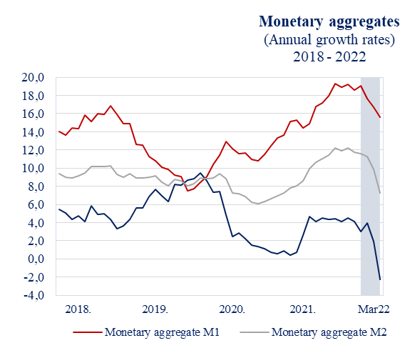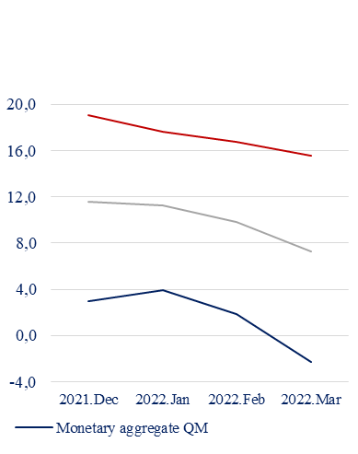

The counter-item of the monthly decrease in the money supply (M2) in March 2022 by KM 544.8 million (1.73%) is a decrease of net foreign assets (NSA) by KM 678.3 million (3.6%) and growth of net domestic assets (NDA) by KM 133.5 million (1.1%). The increase of 2.1 billion KM (7.3%) in the money supply (M2) at the annual level is the result of the growth of net foreign assets (NSA) by 2.0 billion KM (12.1%) and net domestic assets (NDA) by KM 116.0 million (0.9%).

Monetary survey
 | Balance in mil. KM | Monthly changes in mil. KM |  |  | Annual growth rate in %
 | III 2022 | I 2022 | II 2022 | III 2022 | I 2022 | II 2022 | III 2022
Assets
1. Net foreign assets | 18,319.1 | 143.7 | -262.7 | -678.3 | 19.6 | 17.3 | 12.1
1.1 Foreign assets | 20,159.7 | 54.4 | -270.8 | -689.3 | 15.3 | 13.5 | 9.4
1.2 Foreign liabilities | -1,840.6 | 89.3 | 8.1 | 11.0 | -15.9 | -14.7 | -12.2
2. Net domestic assets | 12,604.6 | -49.6 | 121.5 | 133.5 | 0.3 | 0.1 | 0.9
2.1. Claims on central government  (net) cantons and municipalities | -213.9 | 21.2 | 3.0 | -17.1 | -136.8 | -136.7 | -143.0
2.2 Claims on local sectors | 20,214.0 | -127.8 | 135.6 | 218.9 | 3.8 | 4.0 | 4.4
2.3 Other items | -7,395.5 | 57.0 | -17.0 | -68.3 | -0.8 | 0.3 | 0.4
Liabilities
1 Money supply (M2) | 30,923.7 | 94.1 | -141.2 | -544.8 | 11.2 | 9.8 | 7.3
1.1 Money (M1) | 17,825.4 | -61.0 | 50.2 | -91.4 | 17.6 | 16.7 | 15.6
1.2 Quasi money (QM) | 13,098.3 | 155.1 | -191.4 | -453.5 | 3.9 | 1.9 | -2.3

Loans
At the end of March 2022, total loans to domestic sectors amounted to KM 21.25 billion having increased by KM 195.6 million (0.9%) compared to the previous month. The growth of loans was registered in the household sector by KM 85.8 million (0.8%) and private companies by KM 144.9 million (1.7%). A decrease in growth of loans on a monthly basis was recorded in government institutions by KM 26.2 million (2.3%), public companies by KM 8.6 million (1.7%), and other domestic sectors by KM 0.3 million 0.2%).
The annual growth rate of total loans in March 2022 amounted to (3.8%), nominally 776.7 million KM. Annual growth of loans was registered in the household sector by KM 555.4 million (5.6%), private companies by KM 269.4 million (3.1%) and other domestic sectors by KM 14.0 million (9.2%) ). Decrease in annual growth of loans was registered with government institutions by KM 53.5 million (4.5%) and non-financial public enterprises by KM 8.6 million (1.7%).

Sectorial structure of loans in BH
 | Balance in mil. KM | Monthly changes in mil. KM |  |  | Annual growth rate in %
 | III 2022 | I 2022 | II 2022 | III 2022 | I 2022 | II 2022 | III 2022
Total | 21,249.3 | -142.7 | 119.1 | 195.6 | 3.5 | 3.7 | 3.8
Out of it:
Households | 10,526.4 | -36.6 | 41.6 | 85.8 | 5.3 | 5.5 | 5.6
Private companies | 8,926.5 | -81.4 | 86.2 | 144.9 | 2.2 | 2.2 | 3.1
Government institutions | 1,124.6 | -14.7 | -14.6 | -26.2 | 0.8 | 0.8 | -4.5
Public companies | 505.3 | -4.2 | 7.4 | -8.6 | -3.9 | -2.6 | -1.7
Loans to other domestic sectors | 166.5 | -5.7 | -1.5 | -0.3 | 7.8 | 11.9 | 9.2

Foreign Exchange Reserves
At the end of March 2022 the CBBH foreign exchange reserves amounted to KM 15.96 billion. Compared to the previous month, CBBH foreign exchange reserves decreased by KM 384.8 million (2.4%), while at the annual level an increase of KM 2.32 billion (17.0%) was registered.

